Practice – Interference and Diffraction
Modern Physics

- You drip two water faucets with the same frequency, with each drop from each faucet occurring at the same time. Both resulting waves interfere, causing the first instance of constructive interference (after the center fringe, occurring directly in between the two faucets) to occur at 6 cm from one faucet and 4 cm from the other at one point.
  - What is the wavelength of the water waves produced from the drips?
  - At what path length differences will the first instance of destructive interference occur?

- Consider the two-slit interference experiment by Thomas Young, using the notation in the notes (x = distance from slits to screen, y_{n} = vertical distance from 0th order fringe to the nth order fringe, d = slit separation).
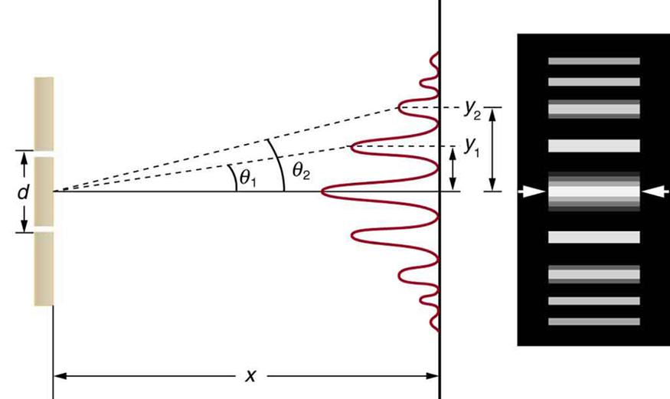
  - Using $\tan{θ}≈\sin{θ}$ and $r_{1}-r_{2}=nλ$ for constructive interference, prove that $y_{n}=n\frac{xλ}{d}$ using the following steps:
    - Find $\sin{θ_{i}}$ in terms of distances given in the picture.
    - Find $r_{1}-r_{2}$ in terms of d and the angle (hint: use similar triangles! You may need to add some lines to the sketch.)
    - Use part ii. And the definition for constructive interference, along with i. to arrive at the intended equation.
  - If you have a red laser with wavelength 650 nm shining through two slits onto a screen that is 0.5 m away from the slits, with the first order (n = 1) fringe occurring 1 mm from the 0th order (central) fringe, how far should the two slits be from each other?
  - For what wavelength of light would the second order (n = 2) fringe be occurring at this distance if the slit separation is given by your answer in part b? Is this a visible light wavelength?
  - Find the frequency of the wave from your answer to c.

